**NETWORK AND COMMUNICATION**

**LAB – L25+L26**

**NAME : ARIHANT CHORDIYA**

**REG NO : 15BCE0295**

**QUESTION : C PROGRAM FOR BIT AND BYTE STUFFING ALGORITHM**

**Code (Sender) :**

**#include<stdio.h>**

**int main()**

**{**

**int i=0,count=0;**

**char a[100];**

**printf("Enter the number of bits:");**

**scanf("%s",a);**

**printf("After the bit stuffing:");**

**printf("01111110");**

**for(i=0;a[i];i++)**

**{**

**if(a[i]=='1')**

**count++;**

**else**

**count=0;**

**printf("%c",a[i]);**

**if(count==5)**

**{**

**printf("0");**

**count=0;**

**}**

**}**

**printf("01111110");**

**return 1;**

**}**

**OUTPUT (SENDER) :**

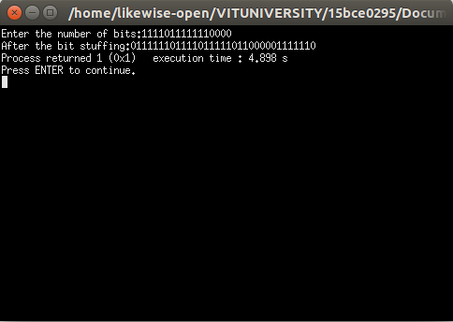

**CODE (Receiver) :**